**Activity**: Genetic Variation at the Molecular level

*AP Biology*

This activity involves two tasks. In task one, you will conduct an analysis of the changes to beta-globin in sickle cell anemia and propose hypothetical explanations of how changes in beta-globin might affect the structure and function of the hemoglobin protein. In task two, you will research the effect of the beta-globin mutation on the structure and function of hemoglobin and compose a brief written response explaining the effect of the mutation and describing how your research has led to the revision and/or expansion of your original hypothesis. Complete all Tasks in your **BILL**.

**Task 1: Analysis of beta-globin sequence (Individual)**

The following sequence data is taken from the coding region of two alleles of the human beta-globin gene. The Hb-b allele produces a phenotypically normal beta-globin molecule. The Hb-s allele produces a beta-globin variant that is associated with sickle cell anemia.

**Hb-b sequence**

| DNA | CAC | GTG | GAC | TGA | GGA | CTC | CTC |
| --- | --- | --- | --- | --- | --- | --- | --- |
| mRNA |  |  |  |  |  |  |  |
| Amino Acids |  |  |  |  |  |  |  |

**Hb-s sequence**

| DNA | CAC | GTG | GAC | TGA | GGA | CAC | CTC |
| --- | --- | --- | --- | --- | --- | --- | --- |
| mRNA |  |  |  |  |  |  |  |
| Amino Acids |  |  |  |  |  |  |  |

1. Transcribe the sequence data into mRNA and determine the amino acids that will be produced when the sequence is translated at the ribosome. A codon chart has been provided for your reference.
2. Use the amino acid chemistry chart to color-code the amino acids in the Hb-b and Hb-s sequences:
   1. Color any nonpolar amino acids yellow.
   2. Color any polar amino acids green.
   3. Color any amino acids with positively charged side chains orange.
   4. Color any amino acids with negatively charged side chains purple.
3. Use the results of your analysis to answer the questions:
   1. What is the difference between the Hb-b allele and the Hb-s allele at the DNA level?
   2. How does the difference that you have described affect the amino acid sequence?
   3. Propose an explanation for how this mutation might affect the structure and function of the Beta-globin polypeptide.

**Codon chart needed for Task 1:**

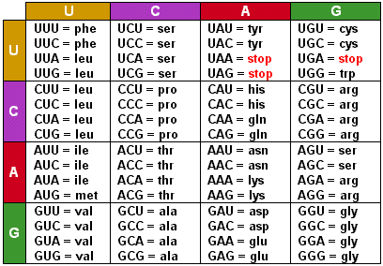

**Amino acid chemistry chart needed for Task 1:**

| **Positively charged amino acids:**   * Arginine (ARG) * Histidine(HIS) * Lysine (LYS) | **Negatively charged amino acids:**   * Aspartic Acid (ASP) * Glutamic Acid (GLU) |
| --- | --- |
| **Polar, uncharged amino acids:**   * Serine (SER) * Cysteine (CYS) * Threonine (THR) * Tyrosine (TYR) * Asparagine (ASP) * Glutamine (GLN) | **Nonpolar amino acids:**   * Alanine (ALA) * Tryptophan (TRP) * Isoleucine (ILE) * Phenylalanine (PHE) * Leucine (LEU) * Glycine (GLY) * Methionine (MET) * Proline (PRO) * Valine (VAL) |

**Task 2: Check your hypothesis**

Conduct independent research to address each of the following:

1. How does the mutation in sickle cell anemia affect the structure and function of the hemoglobin molecule?
2. Relate your answer to your hypothesized explanation in question 2C of Task 1.
3. Explain how your original answer has been revised and/or expanded as a result of your research.